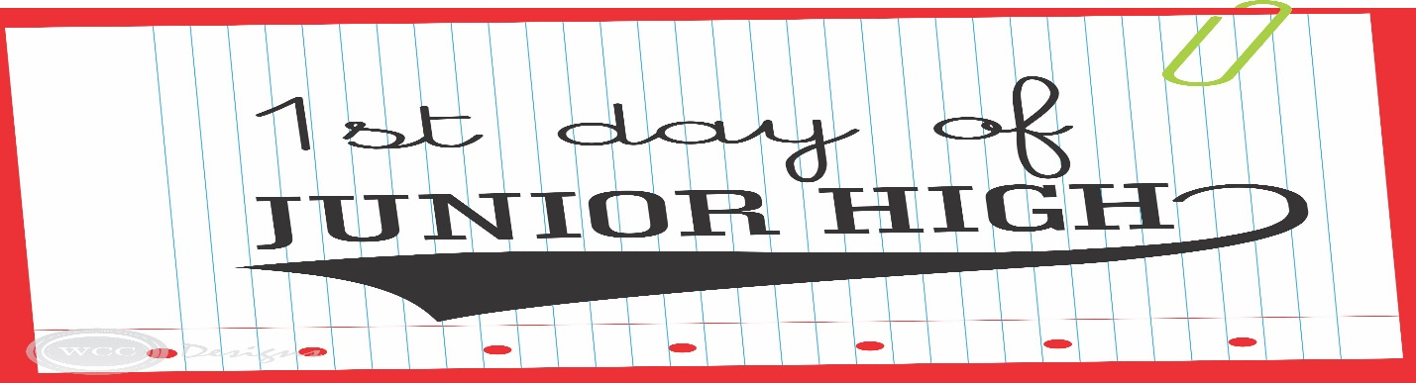

**Basic Supplies students will need for each class:**

10 black pens Student Planner (provided by PHJH)

10 blue pens Pencil/pen pouch

Colored pencils 1 metric/customary ruler (cm or mm/inches)

12-24- #2 sharpened pencils Trapper Keeper/Binder with dividers

1 ream of loose leaf notebook paper 6 Folders

6 spiral notebooks (4 Star- non separating pages) Glue sticks

Pencil sharpener (with cover) 1 Bottle of hand sanitizer (for Advisory Class) 1 Box of tissues (for Advisory Class)

**Additional Supplies by Subject Area**

**ELA:** **Math:**

Correction tape Pack of graph paper (1/4” squares)

Erasable blue or black pens Texas Instruments Calculator #TI30XS

Composition notebooks Protractor

**Social Science: Art:**

Highlighters Big eraser

Watercolor paint set

2 boxes of tissue

2 rolls of paper towels